# UNIT 3

**Multimedia**



Picture 3.1

**Learning Outcomes**:

By the end of the lesson, the students are expected to be able to use appropriate English to:

* describe toolbox from a graphics package and multimedia equipment
* read and understand texts about MP3 and Video Games
* identify time clauses
* identify passive voice
* tell a process of creating and editing picture, audio, or video using time clauses and passive voice

**3.1 Describing Toolbox from a Graphics Package and Multimedia Equipment**

**Exercise 1**: Study this toolbox from a graphics package. Find the icons which represent these features.

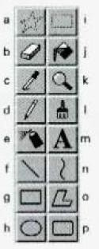

1. Text
2. Eraser
3. Polygon
4. Rectangle
5. Air brush
6. Select
7. Color fill
8. Curve

**Exercise 2**: Match the photos with the multimedia equipment in the box.

Headphones Microphone Projector

Virtual reality goggles Webcam

Speakers

Video camera

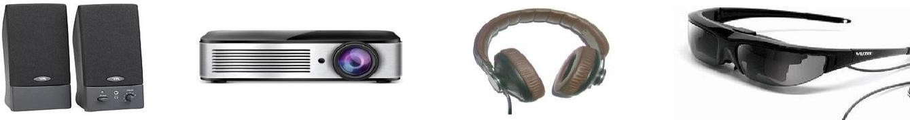1.

1. 2.

3.

4.

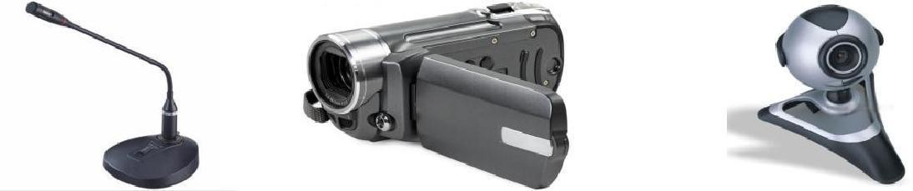

6.

5.

7.

1. Speakers, the function is given sound or audio generally.
2. Projector, the function is showing display screen with bigger size.
3. Headphone, the function is given sound or audio personally.
4. Virtual reality goggles, the function are
5. Microphone
6. Video camera is
7. Webcam, the function

**3.2 Reading and Understanding Texts about MP3 and Video Games**

**Exercise 3**: Read this text to find the answers to these questions.

**Understanding MP3**

The name comes from MPEG (pronounced EM-peg), which stands for the Motion Picture Experts Group. MPEG develops standards for audio and video compression. MP3 is actually MPEG Audio Layer 3.

MP3 competes with another audio file format called WAV. The key difference is that MP3 files are much smaller than WAV files. An MP3 file can store a minute of sound per megabyte, while a WAV file needs 11 or 12 megabytes to hold the same amount. How does MP3 achieve this compression? CDs and audio files don't reproduce every sound of a performance. Instead, they sample the performance and store a discrete code for each sampled note. A CD or WAV file may sample a song 44, 000 times a second, creating a huge mass of information.

By stripping out sounds most people can't hear, MP3 significantly reduces the information stored. For instance, most people can't hear notes above a frequency of 16kHz, so it eliminates them from the mix. Similarly,

It eliminates quiet sounds masked by noise at the same frequency. The result is a file that sounds very similar to a CD, but which is much smaller. An MP3 file can contain spoken word performances, such as radio shows or audio books, as well as music. It can provide information about itself in a coded block called a tag. The tag may include the performer's name, a graphic such as an album cover, the song's lyrics, the musical genre, and a URL for more details.

|  |
| --- |
| 1. What does MP3 stand for? |
| 2. What is the difference between MP3 and WAV files? |
| 3. What kind of sound does MP3 strip out |
| 4. What kind of information is included in the tag? |

**Exercise 4**: Complete the text with the words in the box.

3graphics 1consoles 2video games 4interactive 5multi player

There are games you play on video (1)consoles such as Nintendo, Sega, and the PlayStation. Moreover, there are games you play on a computer, either alone or at multiplayer online sites such as Microsoft’s Internet Gaming Zone and Battle.net.

(2)video games have been made into films, such as Mortal Kombat 1 and 2, and film stars now sometimes appear in video games. The (3)graphic in many games have taken on such a high degree of realism that they almost seem like film. The X-Files game was practically an (4)

interactive movie, full of actors from the show and sections of dialog and video. Some people claim that the Blade Runner video game was better than the movie – not only were the sets incredible but you also got to control the action and the ending.

(5)multi player online gaming is the next wave in the video game world. It provides a better gaming experience, simply because people are more active and more challenging adversaries than computers. Thousands of people can play simultaneously all over the world.

*Professional English in Use ICT, p.41*

**3.2 Telling a process of creating and editing picture, audio, or video using time clauses and passive sentences**

**Exercise 5**: Read this following explanation about time clauses. Then do the exercise.

Study these steps in the production of a graphic:

1.

2.

3.

4.

5.

6.

7.

8.

9.

10.

The basic design is drawn.

Detail is added.

Unnecessary parts are removed using the eraser. The graphic is scaled to the right size.

The drawing is complete. Color is added.

Text is added.

The author works on the graphic. The graphic is ready to print.

The finished product is printed.

The sentences above can be linked using time words, such as *after* and *before*

which indicate the sequence in which things happen.

For example:

1+2 → *After* the basic design is drawn, detail is added.

3+4 → *Before* the graphic is scaled to the right size, the unnecessary parts are removed using the eraser.

Besides, the time word *when* can also be used to indicate one action happens immediately after another.

For instance:

5+6 → *When* the drawing is complete, color is added.

The other time word is until which links an action with the limit of that action. For example:

8+9 → The author works on the graphic *until* it is ready to print.

Study these steps in the production of a desktop-published student magazine.

1. Text is typed using a word processor.
2. The text is edited.
3. The text is spellchecked.
4. Line drawings are made using a graphics package.
5. Photographs are scanned with scanner.
6. The first draft is completed.
7. The first draft is transferred to a page-make up program.
8. Text and graphics are adjusted on screen.
9. They all fit together.
10. The finished document is printed on a laser printer.

Link these pairs of sentences using these time words.

|  |  |  |
| --- | --- | --- |
| a. | 1+2 after | After text is typed using a word processor, the text is  edited |
| b. | 2+3 before | Before the text is spellchecked, the text is edited |
| c. | 3+4 after | After the text spellchecked, line drawing are made using  A graphics package |
| d. | 5+6 after | After photographs are scanned with scanner, the first  draft is completed |
| e. | 6+7 when | When the first draft is completed, the first draft is  Transferred to a page-make up program |
| f. | 8+9 until | Text and graphics are adjusted on screen until they all fit  together |
| g. | 9+10 after | After they all fit together, the finished document is  Printed on a laser printer |

**Exercise 6**: Link these pairs of statements with suitable time words to make a description of the

development of computers.

1. Electronic computers were developed.

There were mechanical calculators similar in some ways to computers.

* Before electronic computers were developed, There were mechanical calculators similar in some ways to computers.

1. World War 2 started.

The first electromechanical computer was developed to decipher codes.

* Before world war 2 started, the first electromechanical computer was developed to decipher codes.

1. The war ended.

Bell Laboratories developed the transistor.

1. But it took more than ten years. Transistors replaced valves in computers.
2. Integrated circuits were introduced in the mid-1960s. Developments happened quickly.
3. The first microcomputers came on to the market in the mid-1970s. Desktop computing became reality.

**Exercise 7**: In describing a process, sometimes we use passive sentences. When you state an opinion or a general thought you can also use this type of sentence. Study these samples.

In the present, the passive voice uses the verbs **is** and **are** + past participle of the main verb. The passive voice present is often used to describe:

|  |  |
| --- | --- |
| **Function** | **Examples** |
| Processes | First the basic design **is drawn**, then the  detail **is added**. |
| General thoughts, opinions, and beliefs | The finished image editing **is considered** satisfying by the client.  **It is believed** that 3D printer is the highest achievement in technology development. Photoshop **is seen** as one of the world’s  most popular editing software. |

**Exercise 8**: Now change the following active sentences into passive sentences.

|  |  |  |
| --- | --- | --- |
| 1. | **Active:**  **Passive:** | We update the company website frequently.  The company website is updated by us frequently. |
| 2. | **Active: Passive:** | Over 300,000 students take the online college entrance exam every year.  The online college entrance exam is taken by over 300,000 students every year. |
| 3. | **Active: Passive:** | A company in Korea manufactures this computer parts.  **These computer parts are manufactured by a company in Korea.** |

|  |  |  |
| --- | --- | --- |
| 4. | **Active:**  **Passive:** | You need to open your student account first to do the online final  test.  **Your student account is needed to open to do the online final test.** |
| 5. | **Active: Passive:** | Andrea learns Python language programming this semester.  **Python language programming is learned by Andrea this semester.** |

**Exercise 9**: In a group, make a presentation about telling a process of making or editing

pictures, videos, or music using any software you know. Use time words and the passive voice you have just learned above.